|  |
| --- |
| Institut für Mechanik (MIB) | Universität Stuttgart |
| Curling Spiral Simulation |
| Weekly work summary |

|  |
| --- |
| Abdul Rehman  2-1-2026 |

Contents

Week 1: Degrees of Freedom Analysis and Spiral Mechanism Design 2

1. Theoretical Derivation of Degrees of Freedom 2

2. Parametric Decomposition via Triangulation 2

3. Design Specification and Dimensional Synthesis 2

4. CAD Implementation and Assembly 3

5. Spiral (Mathematical Foundation) 4

Week 2: Literature review and Design in Abaqus 5

# Week 1: Degrees of Freedom Analysis and Spiral Mechanism Design

## 1. Theoretical Derivation of Degrees of Freedom

To define the geometry of a planar quadrilateral for the proposed mechanism, we must first establish the minimum number of independent parameters required to define its shape.

A planar quadrilateral consists of four vertices. In a two-dimensional Cartesian coordinate system, each vertex is defined by an (x, y) coordinate pair, resulting in an initial total of 8 degrees of freedom (DOF):

*4 vertices x 2 coordinates/vertex = 8 DOF*

However, for shape definition, we must eliminate rigid body motions (translation and rotation) which do not affect the intrinsic geometry:

* **Translation:** Fixing one vertex at the origin (0,0) constrains 2 DOF.
* **Rotation:** Aligning one adjacent side along a principal axis (e.g., the x-axis) constrains 1 rotational DOF.

Subtracting these rigid body motions leaves us with the minimum independent parameters required to define the shape:

*8 DOF - 2 (translation) - 1 (Rotation) = 5 DOF*

## 2. Parametric Decomposition via Triangulation

An alternative verification of this result can be achieved by decomposing the quadrilateral into two adjacent triangles.

* **Triangle 1:** A general triangle requires 3 parameters to be fully defined (e.g., Side-Side-Side, Side-Angle-Side, Angle-Angle-Side, or Angle-Angle-Angle).
* **Triangle 2:** The second triangle shares a common side with the first. Since this shared side is already defined by the first triangle, the second triangle requires only 2 additional parameters (e.g., Angle-Angle , Side-Side or Side-Angle) to be fixed relative to the first.

Total Independent Parameters: *Three (triangle 1) + two (triangle 2) = 5 DOF*

Consequently, a general quadrilateral can be fully defined by valid combinations of 5 parameters, such as:

* 4 Sides and 1 Angle
* 3 Sides and 2 Angles
* 2 Adjacent Sides and 3 Angles

## 3. Design Specification and Dimensional Synthesis

For the specific application detailed in the *technical report SPIRAL (Park & Wenson)*, the design reduces the complexity of the control parameters to achieve a logarithmic spiral assembly.

To streamline the design, additional constraints were applied to the 5 available degrees of freedom:

* **Fixed Angles:** The internal structure is constrained by fixing the internal angles, reducing the variability.
* **Geometric Progression:** The side lengths follow a strict reduction ratio, creating a self-similar spiral structure.

The design utilizes a recursive assembly of six quadrilaterals. The leading side of the n-th quadrilateral serves as the base for the (n+1)-th quadrilateral. The internal angles are held constant across all iterations to maintain geometric similarity:

* Angle alpha: 80.41 degrees
* beta: 80.41 degrees
* gamma: 80.42 degrees

The side lengths for the six quadrilaterals were calculated based on a fixed reduction ratio, resulting in the following dimensional series:

|  |  |
| --- | --- |
| Quadrilateral ID | Side Length (mm) |
| 1 | 50 |
| 2 | 37.51 |
| 3 | 28.14 |
| 4 | 21.11 |
| 5 | 15.85 |
| 6 | 11.88 |

(Values rounded to two decimal places for brevity, Exact values in SolidWorks files)

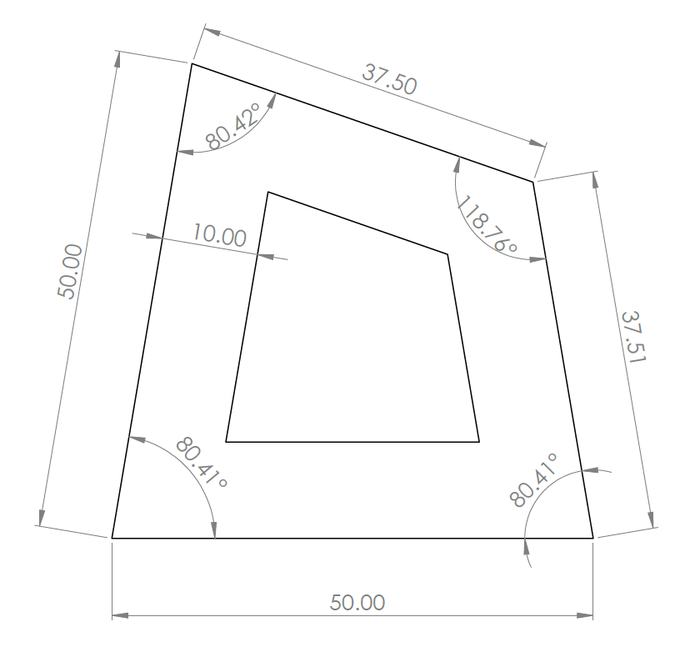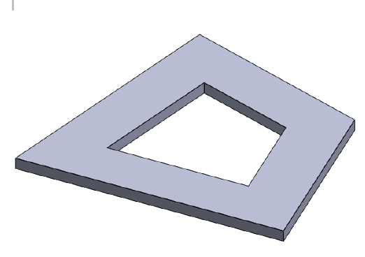

## 4. CAD Implementation and Assembly

Based on the calculated dimensions, the geometry was modeled in SolidWorks. Each quadrilateral was extruded to a thickness of 2mm. The final assembly consists of the six sequential quadrilaterals joined at their common edges. To achieve the complete curling motion achieved in the john Edmark Curling Spiral (Outer Spine) framework, a mirror copy of the primary spiral chain was assembled, completing the mechanism's symmetric profile.



## 5. Spiral (Mathematical Foundation)

The mechanism's profile is derived from the logarithmic spiral. In polar coordinates (r, θ), this curve is defined by the equation:

**r** = a.e**(b.θ)**

Where:

* r (Radius): The distance from the origin (spiral center) to the curve.
* theta(Θ): The angular position of the point in radians.
* a (Scale Factor): This parameter defines the initial size of the spiral. Mathematically, it is the radius when the angle θ = 0. In the context of the mechanism, a correlates to the initial dimension of the first quadrilateral (e.g., the 50mm side).
* B (Growth Rate): This constant controls how rapidly the spiral expands. It determines the "tightness" of the wrapping. A higher value of b results in a rapid expansion, while a lower value creates a tightly wound spiral.

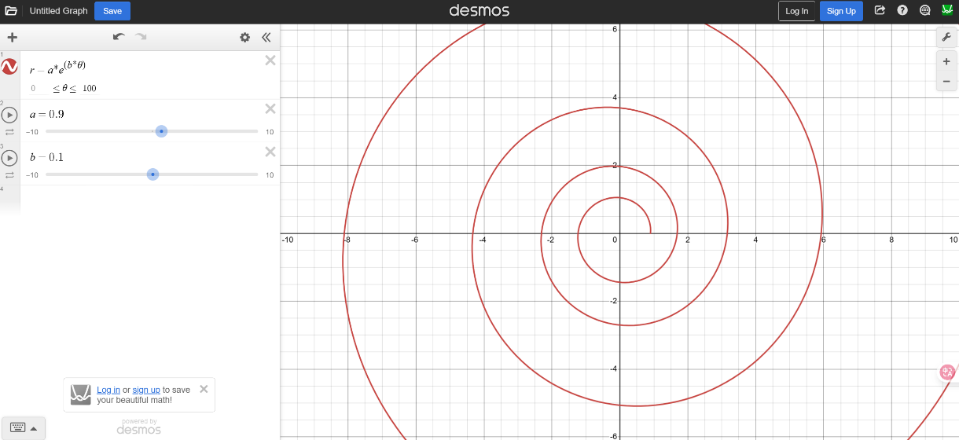

(Reference to John Edmark design <https://www.johnedmark.com/spirals1/2016/4/29/curling-spiral-outer-spine>)

# Week 2: Literature review and Design in Abaqus

Research paper SpiRobs summary:

SpiRobs is a geometric pattern found in animal like octopus arms and elephant trunks. By leveraging this bioinspired design, the researchers developed a system capable of versatile grasping. Robots are designed by discretizing a logarithmic spiral into quadrilaterals and mirroring them to create a body that naturally curls and uncurls.

SpiRobs use an "uncurling-to-reach" motion that allows the robot body to "climb" along an object's surface, automatically adapting to its shape without complex sensors. The design is mathematically consistent across sizes; the researchers successfully demonstrated prototypes ranging from a 1 cm miniaturized gripper to a 1-meter-long. A prototype weighing only 38.4 g was shown to lift a 10 kg load roughly 260 times its own weight. Complexity is shifted from hardware to geometry; the robots achieve lifelike movements using only two or three internal cables connected to standard motors. The robots are fabricated quickly and at low cost using desktop 3D printers and TPU filament.

SpiRobs have a radius of curvature that decreases toward the tip, allowing them to wrap tightly around very small objects. The system detects contact with objects (even a feather) by monitoring spikes in the motor’s electrical current, eliminating the need for expensive tactile sensors. Beyond slow grasping, the robots can perform high-speed tasks, such as "whipping" to catch a ball or throwing objects at speeds up to 10.5 m/s.